YuvaIntern
Amanjeet

Implementation Roadmap & Code Structure Planning
September 04, 2026

1. Introduction
Software development requires proper planning before the actual implementation of a project begins. A well-defined implementation roadmap helps developers understand what needs to be developed, in what order the different components should be created, and how those components will work together. Similarly, planning the code structure before writing the application helps maintain organization and reduces confusion as the project grows.
For this internship task, an Internship and Job Opportunity Management System is considered as the proposed software project. The purpose of this system is to provide a centralized platform where students can discover internship and job opportunities, view relevant details, apply for suitable positions, and track the progress of their applications. At the same time, administrators can manage users, create or update opportunity listings, and monitor submitted applications.
For example, a student logging into the system may search for a Java Developer Internship. The student can view details such as the company name, required skills, eligibility criteria, location, and application deadline. If the opportunity is suitable, the student can submit an application through the system. The application information would then be stored and made available for administrative review.
To implement such a system effectively, the development process should be divided into clear phases instead of attempting to build everything at once. The project can begin with requirement analysis and system design, followed by the development of individual modules such as user authentication, opportunity management, and application management. Testing and deployment can then be performed after the major features have been integrated.
This document presents a proposed implementation roadmap and code structure for the Internship and Job Opportunity Management System. It explains the major development phases, project modules, possible folder organization, technology considerations, coding practices, and potential challenges. The purpose is to create a structured plan that can guide the future development of the project in a systematic and maintainable manner.

2. Project Overview
The proposed project is an Internship and Job Opportunity Management System, designed to provide a centralized platform for managing internship and job opportunities. In many colleges, students often receive information about opportunities through different sources such as WhatsApp groups, emails, notice boards, or social media. Because the information is scattered, students may miss important deadlines or find it difficult to track the opportunities they have already applied for.
The proposed system aims to solve this problem by bringing internship and job opportunities together in one platform. Students will be able to create an account, browse available opportunities, search for specific roles, view detailed eligibility criteria, and submit applications. They will also be able to track the status of their applications, such as Applied, Under Review, Shortlisted, or Rejected.
For example, suppose a company posts a Software Development Intern position requiring knowledge of Java and SQL. A student interested in the role can search for the opportunity, check whether they meet the eligibility criteria, and submit an application through the system. After applying, the student can later log in and check whether the application has been shortlisted or is still under review.
The system will also include an administrative side for managing the platform. Administrators will be able to add new internship or job opportunities, update existing information, remove expired listings, and monitor submitted applications. This will help ensure that the information available to students remains organized and up to date.
The project is planned as a modular software system so that different functionalities can be developed and maintained separately. Major modules may include user authentication, student profile management, opportunity management, application tracking, and administrative management. This structure will make the system easier to understand, test, and extend in the future.
Another important aspect of the proposed system is improving the overall organization of application-related information. Instead of students having to remember which opportunities they applied for manually, the system can maintain a record of submitted applications in one place. For instance, if a student applies for internships at three different companies, the dashboard could display each application along with its current status and relevant deadline. This would make it easier for students to manage multiple applications and help administrators maintain a structured record of available opportunities and applicant information.

📊 Table : Project Overview and Key Features
Aspect | Description | Concrete Examples
Project Name | Internship and Job Opportunity Management System | A centralized platform for career opportunities
Primary Users | Students and administrators | A student searches for internships; an admin posts opportunities
Main Problem | Opportunity information is scattered across multiple sources | A student misses a deadline because the notification was buried in a WhatsApp group
Core Function | Browse and search opportunities | Searching for "Java Developer Internship"
Application Tracking | Monitor application progress | Status changes from Applied → Under Review → Shortlisted
Administrative Control | Manage opportunities and applications | Admin removes an expired internship listing

3. Implementation Roadmap
The implementation roadmap provides a structured plan for how the Internship & Job Opportunity Management System can be developed in the future. Instead of developing all features at once, the project can be divided into different phases. This approach makes the development process easier to understand and helps in completing each part in a proper sequence.
The proposed roadmap begins with understanding the requirements of the system and then moves towards planning the database and project structure. After that, the different modules can be developed and later integrated together. The final stages would focus on testing the system and preparing it for deployment.
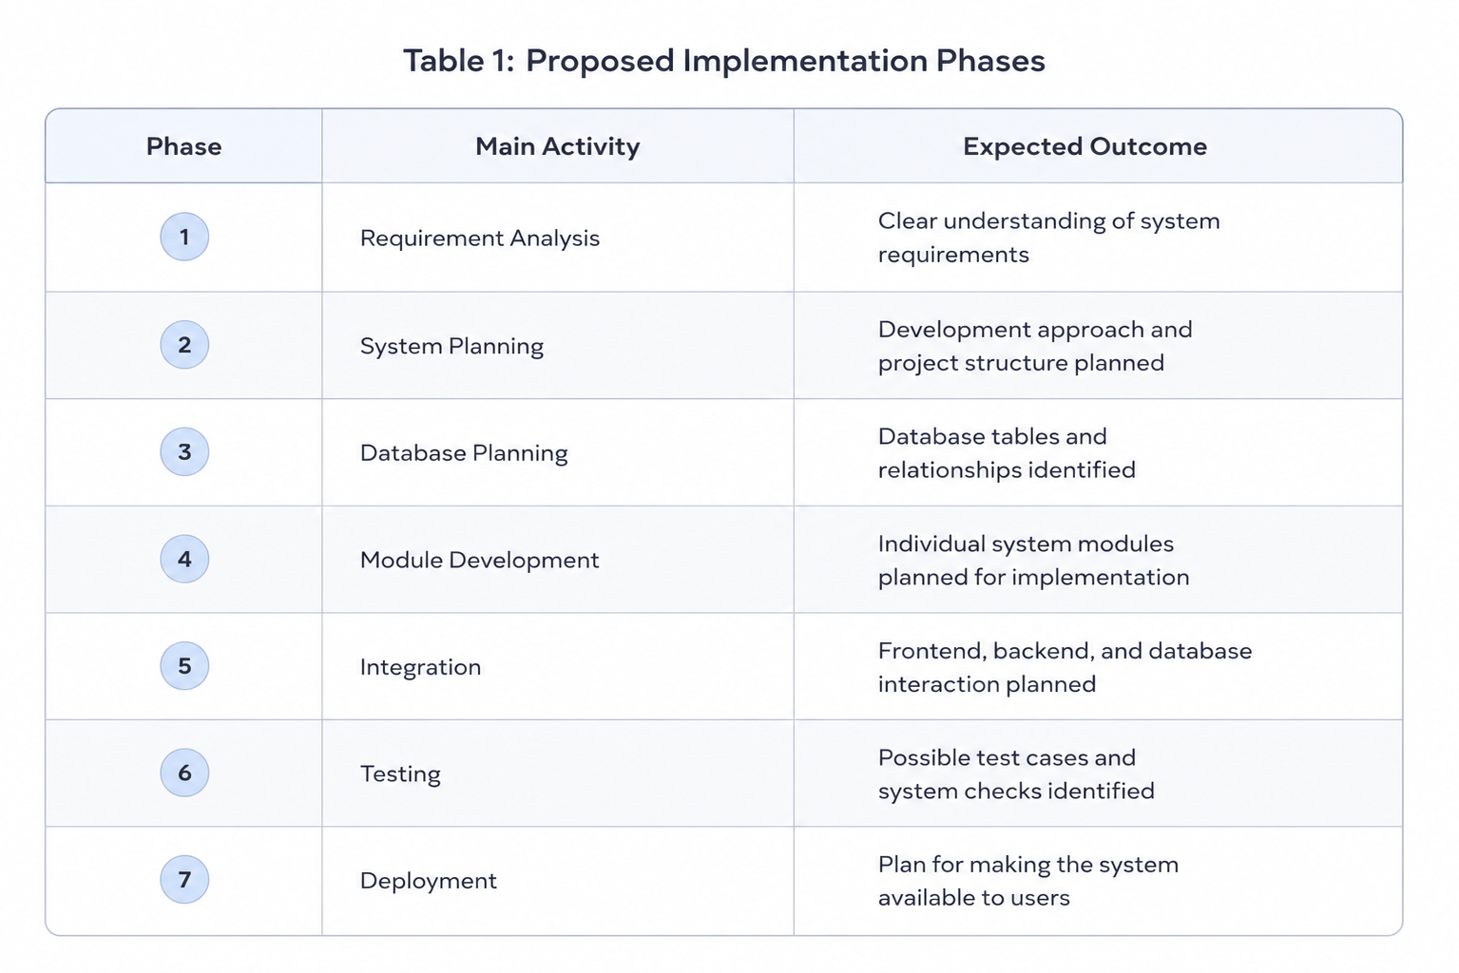

3.1 Requirement Analysis
Requirement analysis is the first stage of the proposed implementation roadmap. The main purpose of this stage is to understand what the system should do, who will use it, and what rules the system should follow.
For the Internship and Job Opportunity Management System, the main users would be students and administrators. Since both users interact with the system differently, their requirements need to be identified separately before development begins.
Key requirements identified for students:
Create an account and log in securely
Browse available internship and job opportunities
Search opportunities based on role, skills, or other relevant criteria
View detailed information before applying
Submit applications for suitable opportunities
Track the current status of submitted applications
Example: A student looking for a Java-related internship could search for available opportunities and view information such as:
Company Name → Job Role → Required Skills → Eligibility → Location → Deadline
Based on these details, the student can decide whether to apply.
The administrator would have a different set of requirements. Their role would mainly involve managing information available on the platform.
Administrator requirements may include:
- Adding new internship or job opportunities
- Updating incorrect or outdated information
- Removing expired opportunities
- Monitoring submitted applications
- Managing user-related information when required
- Another important part of requirement analysis is defining the basic rules of the system.
Some proposed system rules are:
- A student should be logged in before submitting an application.
- A student should not be able to apply multiple times for the same opportunity.
- Expired opportunities should not accept new applications.
- Only authorized administrators should be able to add, edit, or remove opportunities.
These requirements provide a clear foundation for the later stages of development. Once the required features and system rules are identified, the project can move towards planning how those features will be organised and implemented.
3.2 System Planning
After identifying the requirements, the next step is to plan the overall structure of the system. Instead of developing the project as one large block of code, the proposed system can be divided into smaller modules based on their responsibilities.
This approach would make the project easier to understand and manage.
The proposed system can include:
Authentication Module
→ Handles registration, login, and user access
Student Module
→ Manages student profiles and user-related activities
Opportunity Management Module
→ Handles internship and job listings
Application Management Module
→ Manages submitted applications and application status
Admin Module
→ Controls and manages important system information
The modules would work together to complete different tasks within the application.
For example, when a student applies for an internship, the interaction could follow this flow:
Student Login
↓
Select Opportunity
↓
Authentication Verification
↓
Application Submission
↓
Application Details Stored
This planning stage also helps identify which modules need to communicate with each other.
Example: The Application Management Module would need information from both the student account and the selected opportunity. Therefore:
Student Information + Opportunity Information → Application Record
Planning these interactions before implementation can reduce confusion later. It also helps create a clearer development structure where each module has a specific responsibility.

3.3 Database Planning
Database planning is important because the proposed system needs to store and manage different types of information. Before implementation begins, it is necessary to identify what data will be required and how different records will be connected.
The main information in the proposed system can be organised into several entities.
Proposed data entities:
Users
→ Stores user ID, name, email, password, and role
Opportunities
→ Stores company name, job title, skills, eligibility, location, and deadline
Applications
→ Stores application-related information and current status
Notifications
→ Stores updates that need to be communicated to users
One of the most important relationships in the system would be between students and opportunities.
A student may apply for multiple opportunities, while a single opportunity may receive applications from multiple students. Therefore, the Application record can act as a connection between the two.
The relationship can be understood as:
Student → Submits → Application → Related to → Opportunity
Example of an application record:
Student ID: ST102
Opportunity ID: JOB205
Application Date: 15 August 2026
Status: Under Review
When a student applies for an opportunity, the system would create an application record containing the relevant information.
Proper database planning would make it easier to retrieve information later. For example:
Student Login → View Application History → Retrieve Related Application Records
Planning these relationships in advance can help reduce duplicate information and make the system easier to maintain.

3.4 Module Development
After the system structure and database have been planned, the project can move towards the development of individual modules. Instead of developing every feature simultaneously, the modules can be implemented one at a time.
A possible development sequence could be:
Authentication
↓
Opportunity Management
↓
Application Management
↓
Notification Features
This approach allows each module to be checked before the complete system is integrated.
Example: Application Management Module
When a student clicks the Apply button, the system could follow the process below:
Verify that the student is logged in.
Check whether the opportunity is currently active.
Check whether the student has already applied.
Store the application details.
Set the initial application status as Applied.
Display a confirmation message.
This process can also be represented simply as:
Student selects opportunity → System validates request → Application stored → Status updated
Developing modules separately would make it easier to identify where problems occur. For example, if application submission is not working correctly, the developer can focus on the Application Management Module instead of checking the entire system.
The modular approach would also support future improvements. New features could be added later without requiring major changes to unrelated parts of the application.

3.5 Integration and Testing
Once the individual modules are developed, they need to work together as a complete system. This stage focuses on connecting the different components and checking whether they exchange information correctly.
For example, submitting an application involves multiple modules:
Authentication Module
↓
Confirms student identity
↓
Opportunity Module
↓
Provides selected opportunity information
↓
Application Module
↓
Stores application details
Even if each module works correctly individually, problems may occur when they interact. Therefore, integration testing would be important.
Important areas to test include:
User login and authentication
Opportunity search functionality
Application submission
Application status updates
Data validation
Communication between modules
Example test case:
Situation: A student attempts to apply for the same internship twice.
Expected Result: The system should detect the existing application and prevent a duplicate record from being created.
Other possible checks could include:
Valid Login → User allowed access
Invalid Login → Access denied
Active Opportunity → Application allowed
Expired Opportunity → Application restricted
Testing these situations would help identify errors before the system is prepared for actual use. Any problems found could then be corrected and tested again.

3.6 Deployment Planning
The final stage of the proposed implementation roadmap is deployment planning. This stage focuses on preparing the completed system so that intended users can access and use it.
Before deployment, the major components of the application should be reviewed to ensure that they are functioning correctly.
Important checks before deployment may include:
User authentication is working properly
Opportunity information is displayed correctly
Applications are stored successfully
User access levels are properly controlled
Important errors are handled appropriately
Database connections are functioning correctly
For example, if the system is deployed as a web application, a student could follow this process:
Open Website
↓
Log In
↓
Browse Opportunities
↓
Select Suitable Position
↓
Submit Application
↓
Track Application Status
The deployment stage should also consider future maintenance. A software system may require updates after it becomes available to users.
Possible future improvements include:
- Email notifications for application updates
- Advanced opportunity filtering
- Resume upload and management
- Company or recruiter accounts
- Recommendation features based on student skills
Therefore, deployment should not be viewed as the final end of the project. It represents the point where the system becomes available for practical use, while future maintenance and improvements can help the application grow further.

4. Development Phases
The Internship and Job Opportunity Management System can be divided into different modules based on the main functions performed by the application. Dividing the system into modules helps keep the project organised and prevents all functionalities from being handled in one large section of the application.
Each module would have a specific responsibility, but they would also interact with other modules when necessary. For example, the Application Management Module would require information from both the Student Module and the Opportunity Management Module before an application can be successfully submitted.
The major modules proposed for the system are:
Authentication → Student Management → Opportunity Management → Application Management → Notification Management → Admin Management
This modular approach would make the future implementation easier to understand, test, and maintain.
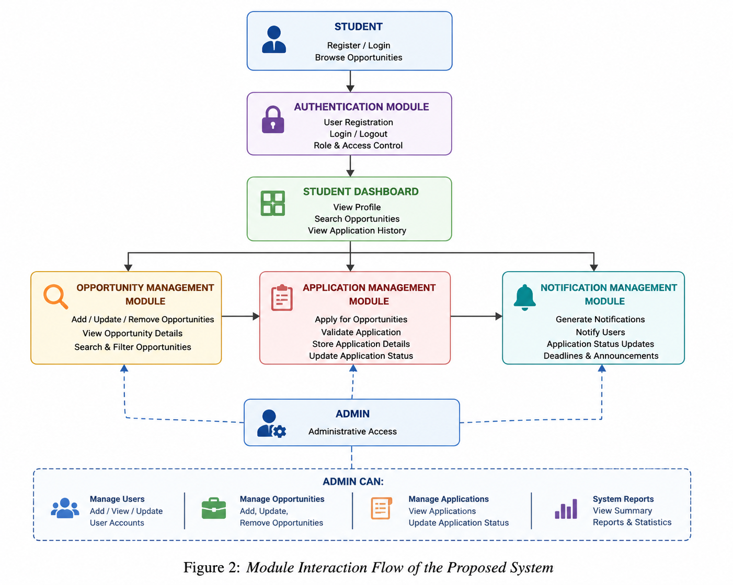
4.1 Authentication Module
The Authentication Module would manage user registration, login, and basic access control. Its main purpose would be to ensure that users are properly identified before accessing protected features of the system.
Main responsibilities:
- User registration
- User login and logout
- Password validation
- User role identification
- Basic access control
Example: When a student enters their email and password, the system would verify the credentials before allowing access to the student dashboard.
User enters credentials → System verifies details → Access granted or denied
This module would also help differentiate between different users. For example, a student should be able to apply for opportunities, while administrative features should only be accessible to authorized administrators.
4.2 Student Management Module
The Student Management Module would handle information and activities related to student users. It would allow students to maintain their basic profile information and interact with opportunities available on the platform.
Possible student-related features:
- View and update profile information
- Browse available opportunities
- Search for specific roles
- View application history
- Track application status
Example: A student interested in software development could update their profile with relevant skills such as Java, SQL, and Python. The student could then search for internships related to those skills.
A typical interaction could be:
Student Login → View Profile → Search Opportunity → View Details → Apply
This module would mainly focus on providing a simple and organised experience for students using the system.
4.3 Opportunity Management Module
The Opportunity Management Module would handle internship and job listings available on the platform. It would store and display the information required for students to understand each opportunity.
Information associated with an opportunity may include:
- Company name
- Job or internship title
- Job description
- Required skills
- Eligibility criteria
- Location
- Application deadline
Example: An administrator could create a new listing for a Java Developer Internship with details such as required Java knowledge, basic SQL skills, location, and the final application deadline.
The information flow could be represented as:
Admin adds opportunity → System stores details → Opportunity becomes visible → Students can view and apply
This module would also be responsible for updating or removing listings when information changes or opportunities expire.
4.4 Application Management Module
The Application Management Module would manage the process of submitting and tracking applications. This is one of the most important modules because it connects students with the opportunities they are interested in.
Basic application process:
Student selects opportunity
↓
System verifies eligibility and application status
↓
Application is submitted
↓
Application record is stored
↓
Initial status is set as "Applied"
The module would maintain information about each submitted application, including the student, selected opportunity, application date, and current status.
Example: If a student applies for a Software Development Internship on 15 August, the system could create an application record with the status Applied. Later, an administrator could update the status to Under Review or Shortlisted.
An important rule of this module could be preventing duplicate applications. If the student has already applied for the same opportunity, the system should detect the existing record instead of creating another one.
4.5 Notification Management Module
The Notification Management Module would be responsible for informing users about important updates. Notifications could help students remain aware of changes related to their applications or new opportunities.
Possible notifications include:
- Application status updates
- New internship opportunities
- Upcoming application deadlines
- Important administrative announcements
Example: Suppose an administrator changes a student's application status from Under Review to Shortlisted.
The flow could be:
Application status updated → Notification generated → Student receives update
Initially, notifications could be displayed within the system. In the future, this module could also be integrated with external services such as email notifications.
4.6 Admin Management Module
The Admin Management Module would provide administrative control over the overall system. Administrators would be responsible for maintaining accurate information and managing important activities on the platform.
Administrative responsibilities may include:
- Managing users
- Adding new opportunities
- Updating existing listings
- Removing expired opportunities
- Reviewing application-related information
- Updating application status when required
Example: If an internship application deadline has passed, an administrator could update the opportunity status to inactive or remove it from the list of available opportunities.
A simplified administrative flow could be:
Admin Login → Access Management Dashboard → Manage Opportunities/Applications → Update System Information
This module would require stricter access control because administrative actions can affect the information visible to all users.

5. Module Breakdown
A proper code structure is important for keeping a software project organised and easy to manage. For the proposed Internship and Job Opportunity Management System, the code can be divided into different modules based on their functionality. This will help in keeping related features together and make the project easier to understand.
Instead of writing all the code in one place, different parts of the system can be separated. For example, login and registration features can be kept under the authentication module, while job and internship-related features can be handled by the opportunity management module. Similarly, application tracking and notification-related functions can be organised separately.
This type of modular structure can make future development easier. If a new feature needs to be added or an existing feature needs to be modified, changes can be made within the relevant module without affecting the complete system unnecessarily. It can also improve code readability and make debugging and maintenance simpler.
The proposed code structure for this project would mainly include modules for authentication, student management, opportunity management, application management, notifications, database operations, and configuration settings. Organising the project in this way would provide a clear foundation for the future implementation of the system.
Proposed Organisation
Project Root
→ Authentication Module
→ Student Management Module
→ Opportunity Management Module
→ Application Management Module
→ Notification Module
→ Database Module
→ Configuration Files
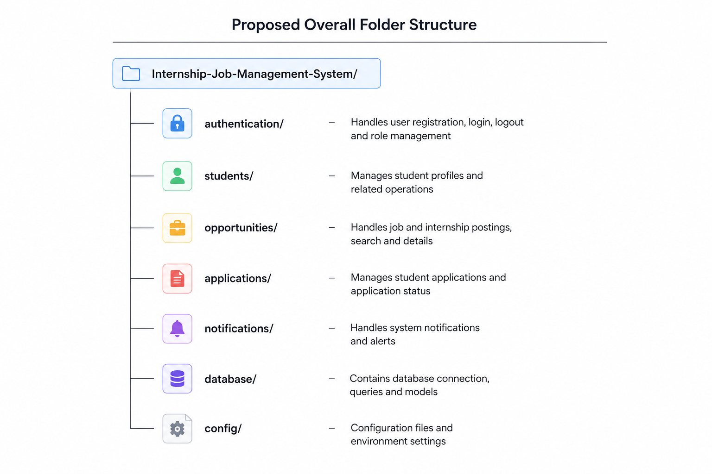

5.1 Overall Project Structure
The proposed Internship and Job Opportunity Management System can be organised into separate modules based on their responsibilities. This approach helps keep the project structured and avoids placing all features in a single section of the code.
Each module will handle a specific part of the system. For example, authentication will manage login and registration, while the opportunities module will handle internship and job listings.
Main modules include:
➤ Authentication – User registration, login and role management.
➤ Students – Student profile and related information.
➤ Opportunities – Job and internship posting, searching and viewing.
➤ Applications – Application submission and status tracking.
➤ Notifications – Alerts and important updates for users.
➤ Database – Data storage, queries and database connectivity.
➤ Configuration – System settings and environment configuration.
This modular structure will make the system easier to understand, maintain and expand in the future.

5.2 Authentication Module
The authentication module will manage user access to the system. It will handle important functions such as registration, login and logout.
Different users may have different roles in the system. For example, students will mainly search and apply for opportunities, while administrators may manage listings and monitor applications.
Main responsibilities:
→ User registration
→ Login and logout functionality
→ Password validation
→ Role-based access
→ Basic user security
Keeping authentication separate from other modules will improve the organisation and security of the project.
5.3 Student Management Module
The student management module will handle information related to student users. Students should be able to create and manage their profiles after logging into the system.
The profile may contain details such as educational information, skills and other relevant information required while applying for opportunities.
Possible features:
➤ Create student profile
➤ Update personal information
➤ Add educational details
➤ Add skills and qualifications
➤ View application history
This module will provide a central place for managing student-related information.

5.4 Opportunity Management Module
The opportunity management module will manage internship and job listings available on the platform. It will allow opportunities to be added, updated and viewed.
Students can use this module to search for opportunities based on their interests or requirements.
Key functions:
→ Add internship or job listings
→ Update opportunity details
→ Search available opportunities
→ View complete descriptions
→ Display eligibility requirements
This module will act as one of the main components of the system because it connects students with available opportunities.
5.5 Application Management Module
The application management module will handle the process of applying for internships and jobs. When a student selects a suitable opportunity, the application details can be stored and tracked through this module.
The system can also maintain the current status of each application.
Application flow:
Student selects opportunity
↓
Application submitted
↓
Application details stored
↓
Status updated
↓
Student checks progress
Possible application statuses may include:
- Applied
- Under Review
- Shortlisted
- Rejected
- Selected
This structure will help students easily track their applications instead of managing them manually.

5.6 Notification and Database Module
The notification module will be responsible for informing users about important updates. For example, students may receive notifications when their application status changes or when new opportunities become available.
Notification examples:
➤ New internship posted
➤ Application successfully submitted
➤ Application status updated
➤ Important system announcements
The database module will store important system information such as:
- User details
- Student profiles
- Job and internship listings
- Applications
- Application status
- Notifications

6. Technical Guidelines
Technical guidelines provide a basic direction for how the proposed Internship and Job Opportunity Management System can be developed. Since the project contains multiple modules and different types of data, following proper development practices can help keep the system organised, secure, and easier to maintain.
The guidelines mainly focus on coding practices, suitable technologies, system design, testing, and basic security considerations. These points can act as a reference during the actual implementation of the project.
6.1 Coding Practices and Standards
During development, maintaining a consistent coding style will be important for keeping the project readable and organised. Since the system contains multiple modules, poorly structured code could make future changes difficult.
Key coding practices include:
- Meaningful Naming – Classes, variables, and methods should have names that clearly describe their purpose.
- Modular Development – Different functionalities should be developed in separate modules instead of placing all logic in one file.
- Code Reusability – Common functionality should be reused wherever possible to reduce unnecessary repetition.
- Proper Formatting – Consistent indentation and formatting should be followed throughout the project.
- Error Handling – Possible errors and invalid user inputs should be handled properly.
- Useful Comments – Comments should explain complex logic without unnecessarily describing obvious code.
Example: Instead of using a vague name such as x, a meaningful name like applicationStatus would make the purpose of the data easier to understand. Following these practices will make the code easier to read, debug, and maintain during future developments.

6.2 Proposed Technology Stack
The technologies for the project should be selected based on simplicity, compatibility, and future scalability. Since the proposed system will manage users, opportunities, and applications, it would require a programming language for the application logic, a database for storing information, and suitable tools for development.

Technology Area | Proposed Option | Purpose
Programming Language | Java | Core application logic
Backend Framework | Spring Boot | Building and managing backend services
Database | MySQL | Storing users, opportunities, and applications
Frontend | HTML, CSS, JavaScript | User interface development
Version Control | Git and GitHub | Managing project versions and collaboration
Development Environment | IntelliJ IDEA / VS Code | Writing and testing code

Simple technology flow:
Frontend → Backend Application → Database
This combination would provide a structured starting point for the future implementation of the project. The technologies can also be changed or expanded later depending on the final requirements.

6.3 Design Principles and Best Practices
The system should follow a simple and organised design so that different components can work independently while still communicating when required. A modular design would be suitable because each major functionality has a specific responsibility.
Important design principles:
➤ Separation of Responsibilities
Each module should focus on its own task. For example, authentication should manage user access, while application management should handle submitted applications.
➤ Loose Dependency Between Modules
Modules should avoid depending too heavily on each other. This can make future changes easier.
➤ Reusable Components
Common features should be designed so they can be reused in different parts of the system.
➤ Clear Data Flow
Information should move through the system in an organised manner.
For example:
Student Login → Authentication → Access Dashboard → Select Opportunity → Submit Application
Following these principles can make the project easier to expand without making the structure unnecessarily complex.
6.4 Testing and Quality Assurance
Testing will be important to ensure that the proposed system behaves correctly under different situations. Instead of checking only whether a feature works normally, testing should also consider invalid inputs and unexpected user actions.
Some important areas to test include:
- User registration and login
- Opportunity searching and viewing
- Application submission
- Duplicate application prevention
- Application status updates
- Database storage and retrieval
Example test scenario:
Action: A student tries to apply for the same internship twice.
Expected Result: The system should detect the existing application and prevent a duplicate record from being created.
Another simple flow could be:
Test Feature → Identify Error → Fix Issue → Test Again
Regular testing during development can help identify problems early and improve the overall reliability of the application.
6.5 Security and Maintainability Considerations
Since the system will store user accounts and application-related information, basic security measures should be considered during development. User access should be controlled based on their role, and sensitive information should be handled carefully.
Basic security considerations:
- Authentication before accessing protected features
- Role-based access for students and administrators
- Input validation to reduce incorrect data
- Secure handling of passwords
- Restricting unauthorized modification of opportunities and applications
For example, a student should be able to submit and view their own applications, but should not be able to access administrative controls or modify another student's information.
Maintainability should also be considered from the beginning. Keeping the project modular and following consistent coding practices would make future updates easier.
Modular Structure → Easier Debugging → Easier Updates → Better Maintainability
By following these technical guidelines, the proposed system can have a cleaner development process and a stronger foundation for future implementation.

7. Potential Roadblocks and Solutions
During the implementation of the proposed Internship and Job Opportunity Management System, several technical and organizational challenges may arise. Identifying these potential roadblocks at the planning stage is important because it allows suitable solutions to be prepared before they significantly affect the development process.
The system contains multiple interconnected components such as user management, opportunity listings, application tracking, frontend interfaces, backend services, and database operations. Therefore, a problem in one component may affect the overall functioning of the system. Proper planning, modular development, testing, and documentation can help reduce these risks.
The following table identifies some possible challenges that may occur during implementation and suggests practical approaches to handle them.

📌 Table 3: Potential Roadblocks and Proposed Solutions
Potential Roadblock | Possible Impact on Project | Proposed Solution
Complex Database Relationships | Managing connections between students, companies, opportunities, and applications may become difficult. | Design the database carefully using proper relationships, primary keys, and normalization techniques.
Invalid or Incomplete User Input | Incorrect information may be stored in the database and affect system reliability. | Apply validation checks on both the frontend and backend before storing data.
Authentication and Security Issues | Unauthorized access could affect user information and application data. | Implement secure login mechanisms and proper password protection.
Module Integration Problems | Errors may occur when connecting frontend, backend, and database modules. | Develop and test each module separately before integrating the complete system.
Changing Project Requirements | New features may require changes to the existing system structure. | Follow a modular design so that new features can be added with minimal impact on existing modules.
Code Maintainability Issues | Poorly structured code can become difficult to understand and modify. | Follow coding standards, meaningful naming conventions, and proper documentation.
Data Consistency Problems | Duplicate or incorrect application records may affect the accuracy of the system. | Use database constraints and validation rules to maintain consistent data.
Limited Testing | Undetected bugs may cause problems during final implementation. | Perform regular testing of individual modules and important system workflows.

7.1 Database and Data Management Challenges
One of the major challenges in this project may be managing the relationships between different types of data. For example, a student may apply for multiple internship or job opportunities, while a single opportunity may receive applications from multiple students. Managing these relationships requires proper database design.
To reduce this problem, the database should be designed using clearly defined tables and relationships. Important entities such as Users, Opportunities, Companies, and Applications should be separated logically. Proper use of primary keys and foreign keys can help maintain relationships between these entities.
Approach: Proper Database Design → Defined Relationships → Data Validation → Improved Data Consistency
7.2 Integration Between System Modules
The proposed system consists of different layers, including the frontend, backend, and database. These components need to communicate correctly with each other. A problem in API communication or data transfer could cause the application to behave unexpectedly.
For example, when a student submits an application, the frontend must send the correct request to the backend. The backend must process the request, validate the information, and store the data correctly in the database.
To manage this challenge, each module should first be tested independently. After individual testing, the modules can be gradually integrated into the complete system.
Recommended approach:
Frontend Development → Backend API Testing → Database Connection → Module Integration → System Testing
7.3 Security and User Authentication
Since the system may contain personal user information and application details, security should be considered during implementation. Unauthorized access to user accounts or modification of application records could affect the reliability of the platform.
The system should therefore include a structured authentication mechanism. User credentials should be handled securely, and access to certain features should depend on the role of the user.
For example:
Students can search and apply for opportunities.
Companies or administrators can manage opportunity listings.
Unauthorized users should not be able to access restricted features.
This type of role-based structure can improve both security and organization within the application.
7.4 Maintaining Code Quality and Scalability
As the project grows, the codebase may become larger and more complex. Without proper organization, adding new features or fixing existing problems can become difficult.
To avoid this issue, the project should follow a modular code structure. Each major functionality should be separated into appropriate modules or packages. Meaningful variable names, proper indentation, comments, and documentation should also be maintained.
This approach will make the project easier to understand and allow future developers to modify or extend the system more efficiently.
Key Principles
Modularity → Separate responsibilities into manageable components.
Consistency → Follow common coding standards throughout the project.
Maintainability → Write code that is easy to understand and modify.
Scalability → Keep the structure flexible for future features.
Testing → Identify and fix problems during development.
7.5 Risk Mitigation Strategy
The overall approach for handling potential roadblocks is to identify problems early and address them systematically. Instead of developing the entire application at once, the project can be implemented in smaller stages.
Each stage should include planning, development, testing, and review. Git and GitHub can also be used to track changes and maintain different versions of the project.
Potential Problem
↓
Early Identification
↓
Appropriate Solution
↓
Module Testing
↓
Integration Testing
↓
Continuous Improvement

8. Documentation Strategy
Proper documentation is an important part of the implementation process because it makes the project easier to understand, maintain, and improve in the future. For the proposed Internship and Job Opportunity Management System, documentation will be maintained alongside the development process rather than being prepared only at the end.
The documentation will explain the purpose of different modules, important functions, database interactions, and the way different components communicate with each other. This will help both the developer and any future team members understand how the system works.

8.1 Code Documentation
Important sections of the code should contain short and meaningful comments wherever the purpose of the code is not immediately clear. Comments should explain why a particular approach is being used rather than simply repeating what the code does.
For example, instead of writing a long comment for every line, documentation can be used for:
Explaining complex business logic.
Describing important functions or methods.
Mentioning the purpose of major classes.
Explaining important database operations.
Clarifying API requests and responses.
Simple Rule → Clear Code First → Comments Only Where They Add Meaning
8.2 Project and Module Documentation
Each major module should have a short description explaining its responsibility and its relationship with other modules.
For example:
User Management
→ Handles user registration, login, profiles, and role-based access.
Opportunity Management
→ Manages internship and job opportunity information.
Application Management
→ Handles applications submitted by students and tracks their status.
Database Layer
→ Stores and retrieves system information.
This makes it easier to understand the complete system without having to read the source code.

8.3 Documentation Tools and Practices
The project documentation can be maintained using simple and commonly used tools. README files can provide an overview of the project, while code comments and documentation features can explain individual components.
For Java-based implementation, Javadoc can also be used to generate structured documentation for classes, methods, and other important components.
GitHub can additionally be used to maintain project documentation along with the source code. This keeps the documentation connected with the corresponding version of the project.
Recommended Documentation Flow
Project Overview
↓
Module Description
↓
Class & Method Documentation
↓
API / Database Notes
↓
Testing & Changes
↓
Final Project Documentation
8.4 Maintaining Documentation During Development
Documentation should be updated whenever an important change is made to the system. For example, if a new module is added or an existing module is modified, its documentation should also be updated.
This prevents the documentation from becoming outdated and reduces confusion during future development.
Overall, a consistent documentation strategy will make the project easier to understand, maintain, debug, and extend. It will also provide a clear record of how the proposed system develops from the initial design into a complete software
project.
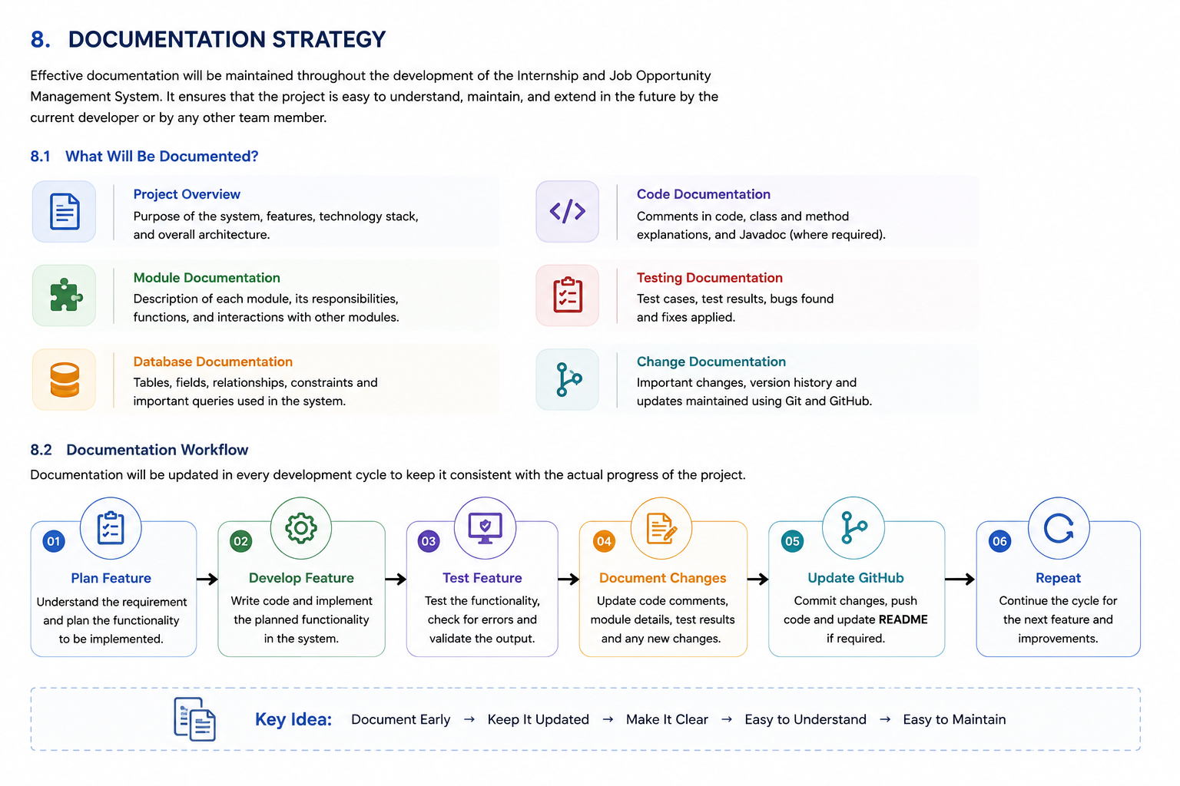

9. Conclusion
The Internship and Job Opportunity Management System has been planned as a structured and practical software solution for managing internship and job opportunities in a more organised way. The main purpose of the project is to provide students with a common platform where they can find suitable opportunities, view important details, submit applications, and track their application status. At the same time, the system is designed to make opportunity and application management easier for the administrator.
Throughout this week, the focus was mainly on planning how the proposed system can be implemented in the future. The implementation roadmap divided the development process into different stages, starting from requirement analysis and system planning, followed by database planning, module development, integration, testing, and finally deployment. Breaking the project into these phases makes the development process easier to understand and reduces the chances of trying to build the complete system at once.
The project was also divided into separate functional modules such as Authentication, Student Management, Opportunity Management, Application Management, Notification Management, and Admin Management. Each module has a specific responsibility and can work together with the other modules to form the complete system. This modular approach can make the project easier to develop, test, debug, and modify when new requirements are introduced.
The proposed code structure further supports this approach by keeping related functionalities in separate sections. For example, authentication-related functions can remain within the authentication module, while opportunity and application-related operations can be handled independently. This can improve code organisation and readability and can also make future maintenance easier.
The technical guidelines provide a basic direction for the future development of the system. Important practices such as meaningful naming, modular development, code reusability, proper error handling, input validation, security, testing, and maintainable code have been considered. The proposed technology stack of Java, Spring Boot, MySQL, HTML, CSS, JavaScript, Git, and GitHub also provides a suitable foundation for converting the planned design into an actual working application.
Another important part of the planning was identifying possible roadblocks and risks before implementation begins. Issues such as complex database relationships, invalid user input, authentication problems, module integration errors, changing requirements, data consistency, limited testing, and code maintenance can affect the development process. Considering these problems in advance allows suitable solutions to be planned rather than dealing with them only after they occur.
Finally, the documentation strategy ensures that important information about the project will be recorded throughout development. Maintaining module descriptions, database information, code documentation, testing details, and project changes will make it easier to understand the system later. Using tools such as GitHub README files, code comments, Javadoc, and the project report can also provide a clear record of the project's progress.
Overall, this week's work provides a clear implementation foundation for the Internship and Job Opportunity Management System. Although the actual coding and complete implementation are still part of the future development stages, the project now has a defined roadmap, module structure, proposed code organisation, technical guidelines, risk considerations, and documentation plan. These preparations can make the next development stages more systematic and manageable.
The main idea is to build the system step by step rather than developing everything together. With a modular structure, proper database planning, regular testing, secure practices, and updated documentation, the proposed system can gradually be converted from the current design into a complete and usable application. The planning completed in this stage will therefore act as a reference during actual implementation, testing, maintenance, and future improvements of the project.

ThankYou
Amanjeet

